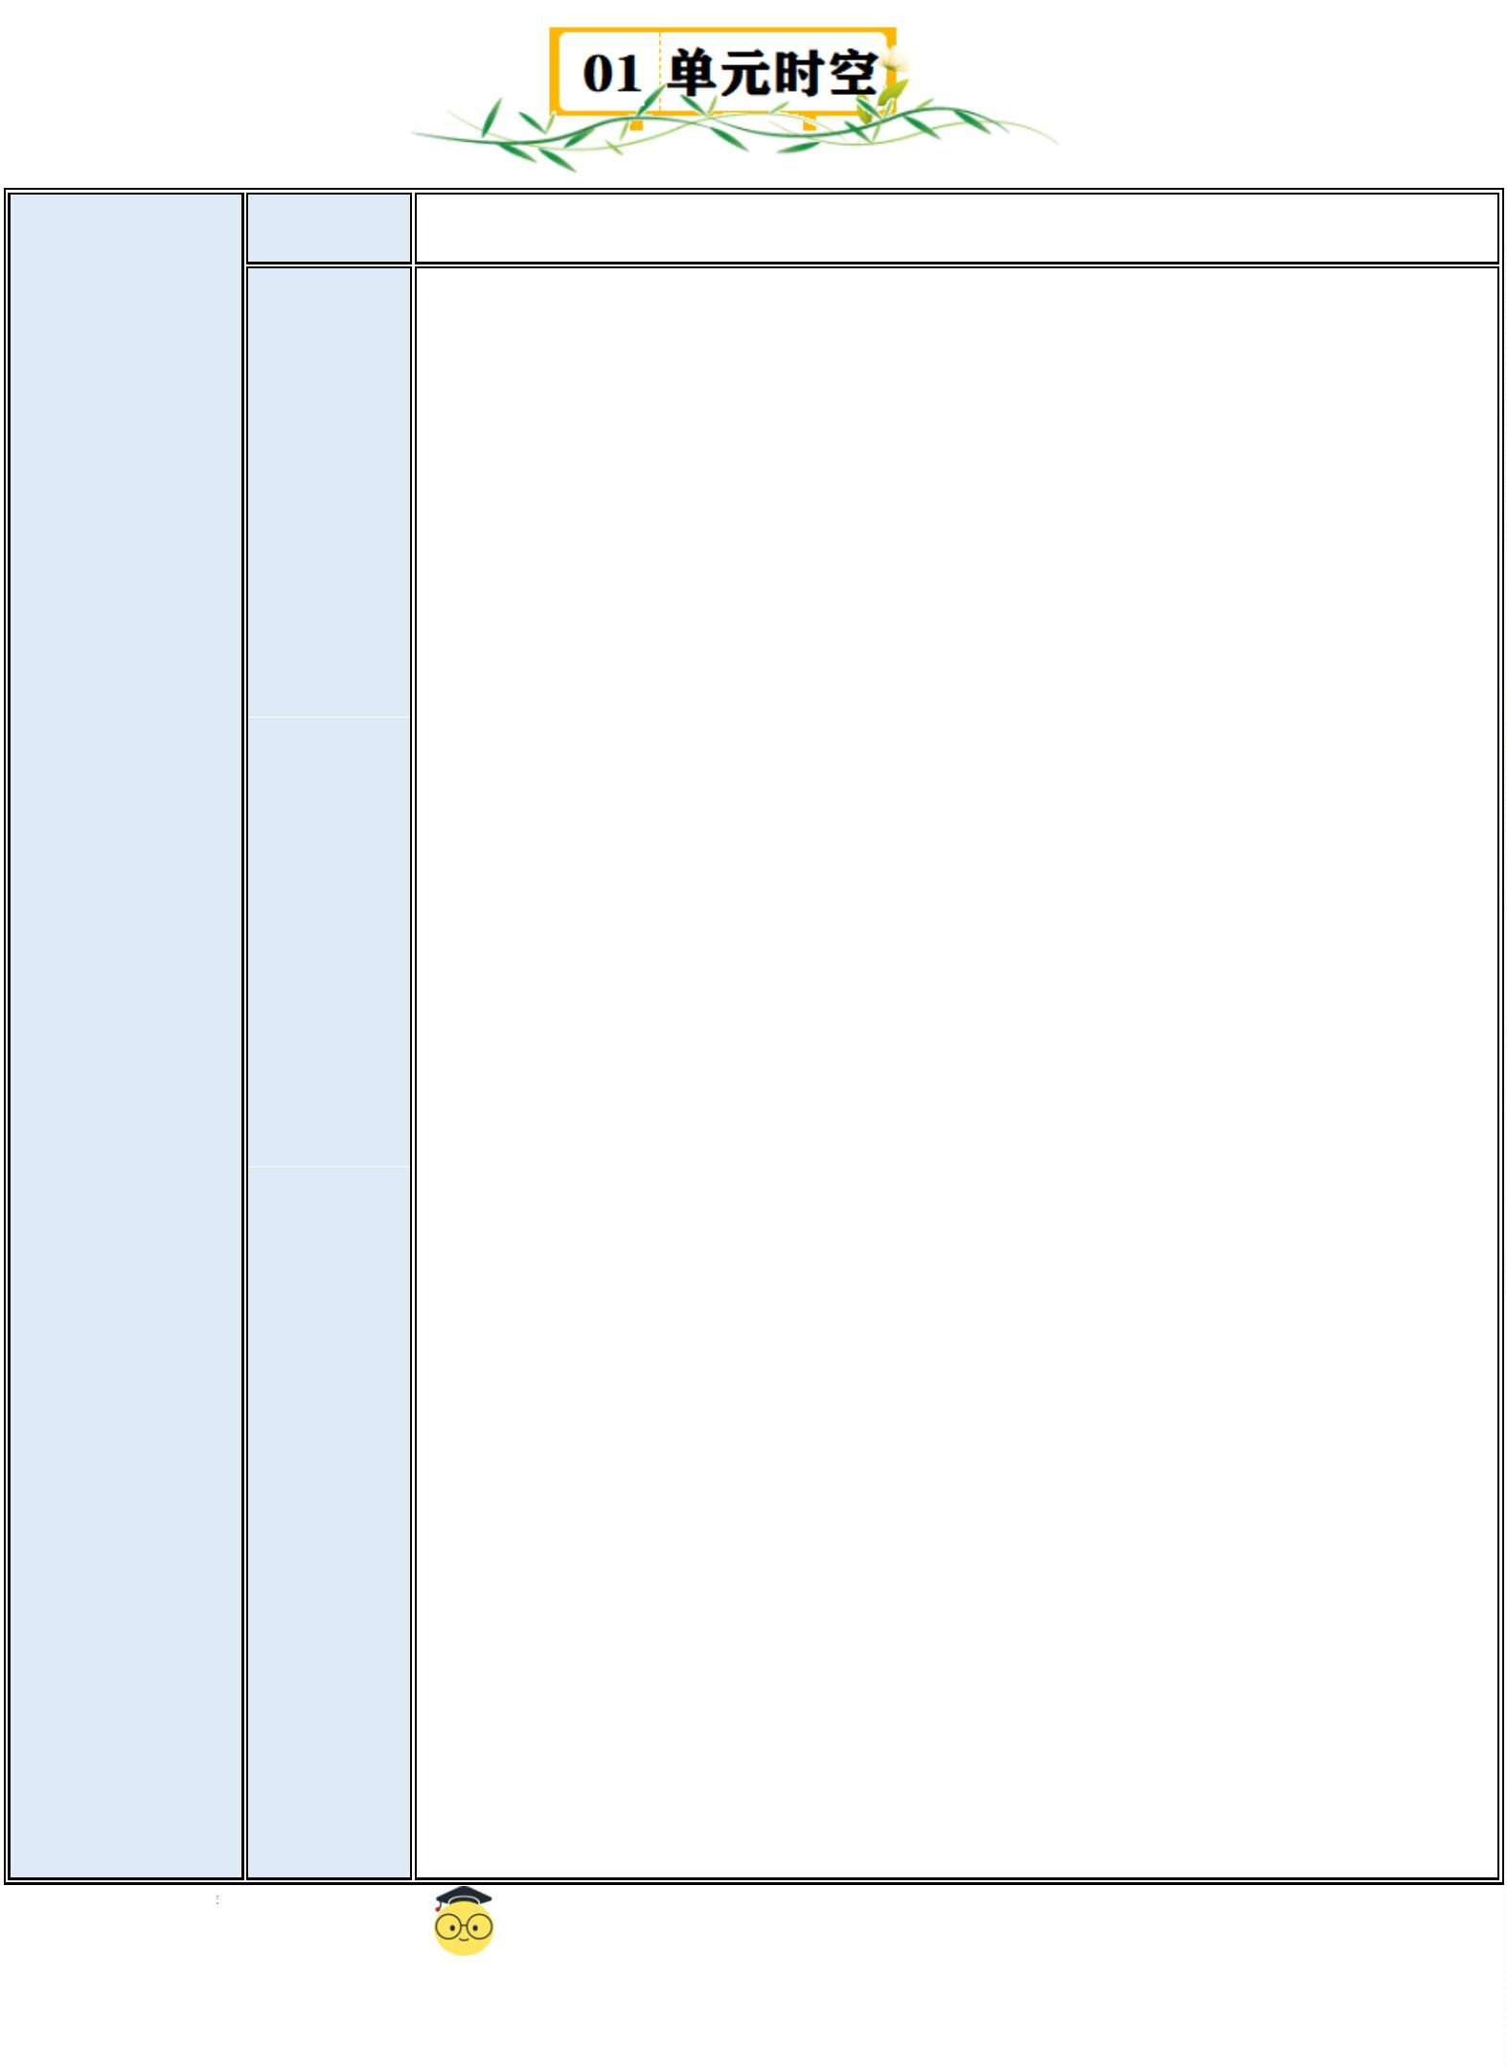Unit2 Rules around us
话题 制度与守则
1.rule /ru:l/ n.规则；规章
2.underground /ˈʌndəɡraʊnd/ n.地铁；地下铁路系统
3.lean /li:n/ v.倚靠；倾斜
4.litter /ˈlɪtə(r)/ v.乱扔 n.垃圾；废弃物
5.gap /ɡæp/ n.缺口；间隙
6.else /els/ adv.其他的；别的
7.escalator /ˈeskəleɪtə(r)/ n.自动扶梯
8.station /ˈsteɪʃn/ n.车站；(服务)台
9.announcement /əˈnaʊnsmənt/ n.公告；通告
10.passenger /ˈpæsɪndʒə(r)/ n.乘客；旅客
Rules
11.lift /lɪft/ n.电梯；升降机
词汇 12.platform /ˈplætfɔːm/ n.站台 around us
13.line /laɪn/ n.线；线条
14.rush /rʌʃ/ v.迅速移动；急促
15.smoke /sməʊk/ v.吸烟；抽烟
16.seat /si:t/ n.座位
17.anyone /ˈeniwʌn/ pron.任何人
18.leave /li:v/ v.留下；离开
19.rubbish /ˈrʌbɪʃ/ n.垃圾；废弃物
20.glove /ɡlʌv/ n.手套
21.broken /ˈbrəʊkən/ adj.破损的；伤残的
22.container /kənˈteɪnə(r)/ n.容器
23.ready /ˈredi/ adj.准备好；准备完毕
1
原创精品资源独家享有版权，侵权必究！
（北京）股份有限公司

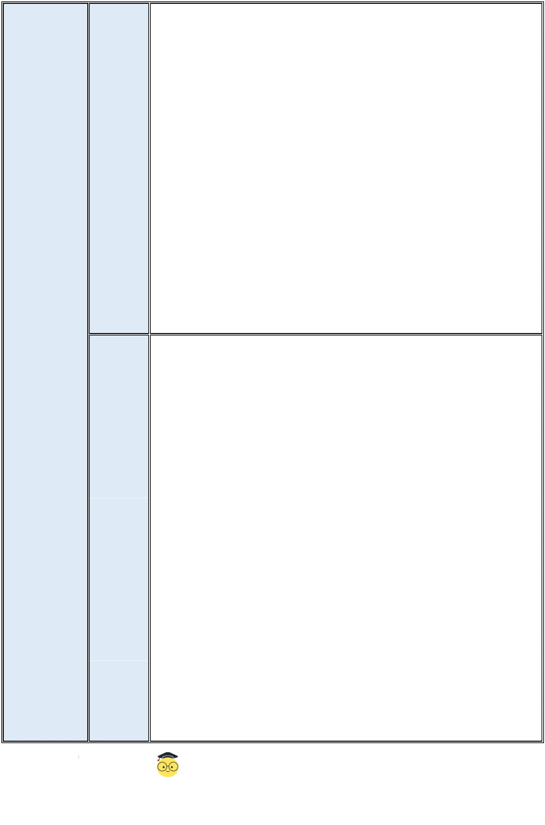24.follow /ˈfɒləʊ/ v.遵循；跟随
25.stay /steɪ/ v.保持；继续是
26.grow /ɡrəʊ/ v.逐渐变得；逐渐成为
27.important /ɪmˈpɔːtnt/ adj.重要的；有重大影响的
28.take turns 轮流；依次
29.hurrah /həˈrɑ:/ excl.万岁；好哇
30.model /ˈmɒdl/ n.模型
31.pay /peɪ/ v.(与某些名词结合使用，表示将来要做或将付出某事物)
32.attention /əˈtenʃn/ n.注意；关注
33.pay attention to(对某人或某事)注意
34.dream /dri:m/ n.梦；梦想
35.outing /ˈaʊtɪŋ/ n.(集体)出外游玩(或学习)；远足
36.gate /ɡeɪt/ n.大门
1.signs and rules 标志和规则
2.see signs everywhere 到处都能看到标志
3.part of our lives 我们生活中的一部分
4.turn right 向右转
5.no leaning 禁止倚靠
6.no littering 禁止乱扔垃圾
7.mind the gap 注意间隙
8.on the escalator 在自动扶梯上 短语
9.in the underground station 在地铁站
10.announcements for passengers 乘客公告
11.on the platform 在站台上
12.give your seat to sb.把你的座位让给某人
13.What’s the meaning of this sign?这个标志是什么意思？
14.rules in different places 不同地方的规则
15.an exchange student 一个交换生
16.look at a display board in the clubroom 看社团教室里的展板
2
原创精品资源独家享有版权，侵权必究！
（北京）股份有限公司

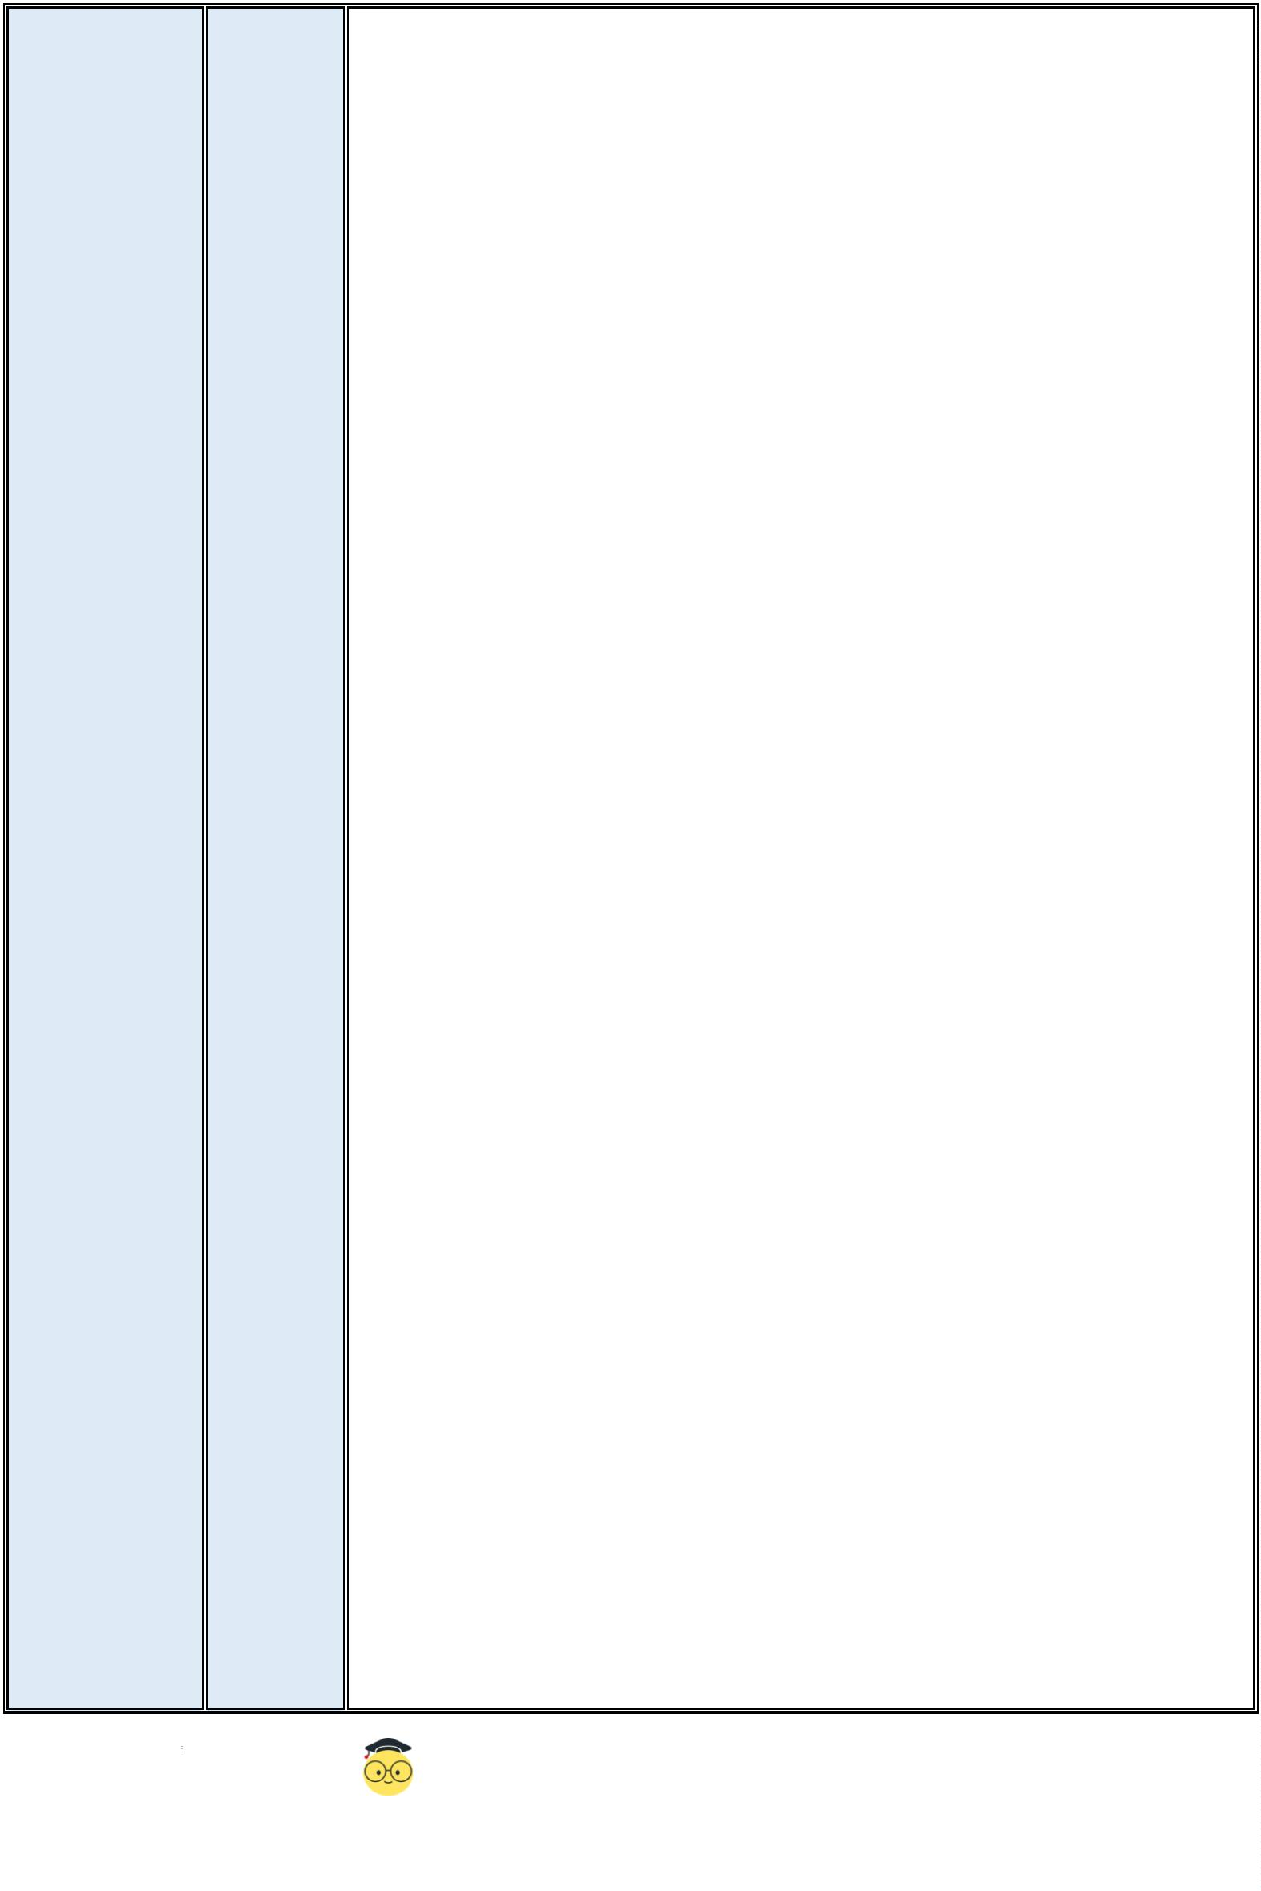17.wear open-toed shoes 穿露趾鞋
18.leave rubbish on the floor 在地上留垃圾
19.wear safety gloves 戴安全手套
20.throw... into...把……扔进……里
21.be interested in 对……感兴趣
22.follow the rules 遵守规则
23.point out 指出
24.be ready to do sth.准备好做某事
25.do some experiments 做实验
26.keep safe 保持安全
27.No food or drinks in the lab.实验室里禁止饮食。
28.stay healthy 保持健康
29.share a rule story with sb.与某人分享一个规则故事
30.talk about rules in class 在课堂上讨论规则
31.a better place without any rules 一个更好的没有规则的地方
32.take turns to do sth.轮流做某事
33.listen to others carefully in class 上课认真听讲
34.show his model plane 展示他的飞机模型
35.pay attention to(对某人或某事)注意
36.keep quiet 保持安静
37.wake up 醒来；唤醒
38.have a dream 做了一个梦
39.hear his mum’s voice 听到他妈妈的声音
40.my opinion of the story 我对于这个故事的观点
41.take Bob’s food without asking 没有询问就拿走鲍勃的食物
42.help us behave well 帮助我们表现得体
43.recommend this story 推荐这个故事
44.a notice for an activity 一项活动的通知
45.write a notice about rules for a school activity 写一份关于学校活动规则的通
3
原创精品资源独家享有版权，侵权必究！
（北京）股份有限公司

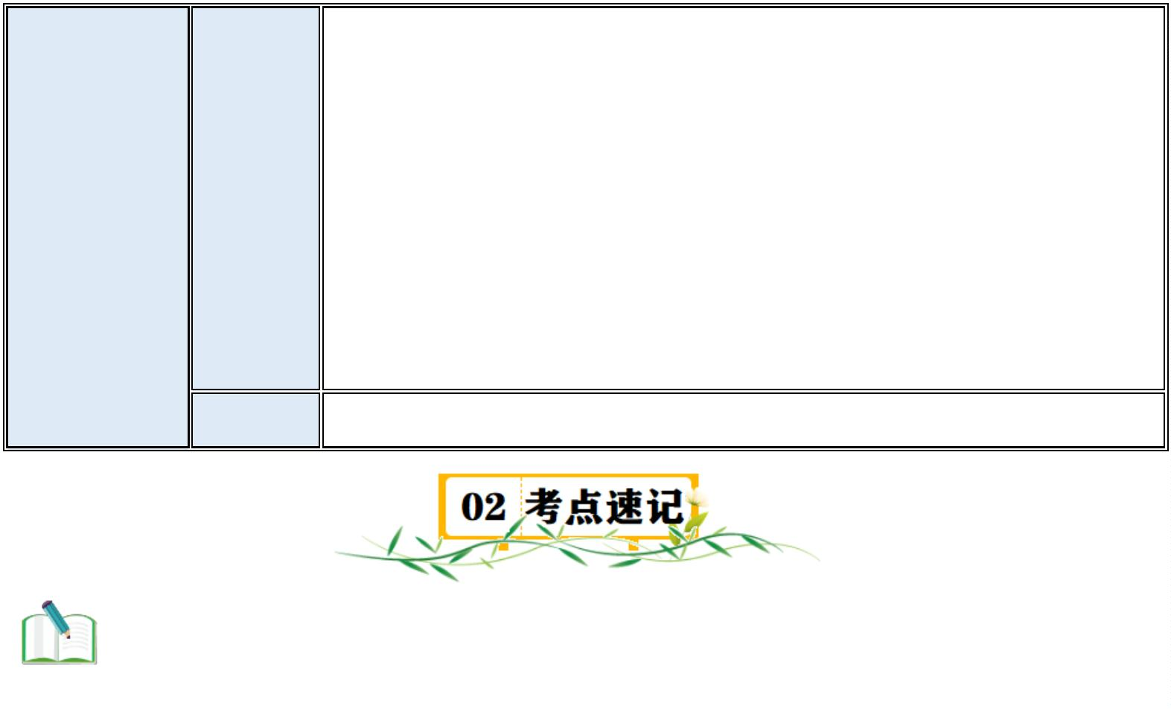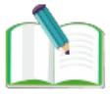知
46.have a spring outing 进行春游
47.the Science and Technology Museum 科技馆
48.meet at the school gate 在学校大门口集合
49.stay with the groups 和小组待在一起
50.No photos.禁止拍照。
51.have a good time 玩得愉快
语法 祈使句和情态动词 must
考点 1. underground n.地铁；地下铁路系统
I go to work by underground every day.=I take the underground to work every day.我每天乘地铁去上班。
【提示】表示地铁这种交通工具时，通常使用 the underground,不能用 an
underground。
如 ：
I usually take a nap when I travel on the underground.我坐地铁的时候通
常会小睡一觉。
虽然这里 on the underground 并不特指某一班地铁，但不能使用 on an underground。
考点 2. lean v. (leaned/leant /lent/,leaned/leant)倚靠；倾斜
She leaned against the wall,feeling tired.她靠在墙上，感觉很累。
“No+动词-ing 形式”是一个常见的英语表达，用来表示禁止或不允许某
种行为。这种结构通常用于标志、通知或规则中，以明确指出某种行为是 不被允许的。
如：
No smoking.(=You mustn't smoke here.)禁止吸烟。 No 后面还可以直接跟名词，用来表示禁止。
如：
No photography/cameras.禁止拍照。
使用 no 表示禁止时，话语通常比较简短，起到警示、警戒作用。
4
原创精品资源独家享有版权，侵权必究！
（北京）股份有限公司

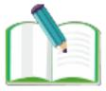考点 3.announcement n.公告；通告
The company will make an important announcement at the meeting.公司将在会议上发布一条重要通告。
We have an announcement about the coming sporting event.关于即将举行的这项体育赛事，我们有一则通
知。
【联想】announce v.宣布，宣告(决定、计划等) announcer n. 广播员；播音员
考点 4. passenger n.乘客；旅客
Please fasten your seat belts,passengers, as we are about to take off.各位乘客，请系好安全带，我们即将起
飞。
announcement for passengers 意为“乘客通告”,是在公共交通工具或站点，如火车、地铁、公交车或机场，
用来向乘客传达信息的正式声明。
如：
Ladies and gentlemen,this is an announcement for passengers.The train is about to arrive at the next
station.Please prepare to disembark.女士们、先生们，这是乘客通告。列车即将到达下一站，请准备下车。
考点 5.smoke v.吸烟；抽烟
Please don't smoke in this area.请不要在这个区域吸烟。
【联想】smoke n.烟雾
The smoke from the fire filled the sky.大火的烟雾弥漫了整个天空。
or 是一个连词，用来连接选项或可能性。但在否定句中，or 通常意味着“和”,而不是提供选择
如：
I don't want tea or coffee.我不想喝茶和咖啡。 (这里意味着两样都不想 要，即：既不想喝茶也不想喝咖啡。)
考点 6. leave v.(left ,left)留下；离开
She left her keys on the table.她把钥匙留在了桌子上。
Please leave the room quietly.请安静地离开房间。
【提示】leave 作动词还有如下的常见用法。
5
原创精品资源独家享有版权，侵权必究！
（北京）股份有限公司

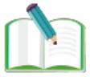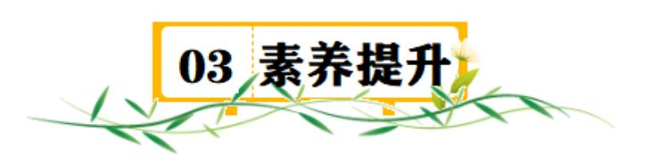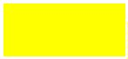(1)表示“忘带；丢下”。
如：
She left her bag on the taxi yesterday.她昨天把包丢在出租车上了。
(2)表示“使保留；让……处于(某种状态、某地等)”。
如：
Leave the door open,please.请把门开着吧。
考点 7.dream n.梦；梦想
I thought someone came into the bedroom,but it was just a dream.我还以 为有人进了卧室，结果只是一场
梦。
Her lifelong dream was to be a famous writer.她的毕生心愿就是成为一 名作家。
【联想】dream v.(dreamt ,dreamt 或 dreamed,dreamed)
做梦；梦见；想象；梦想 have a dream 做梦
I had a strange dream about a fierce wolf.我做了一个非常奇怪的梦，梦 见了一头凶猛的狼。
考点 8.turn 在这里作名词，意为“(依次轮到的)机会”。
When it's your turn, take another card.轮到你时，再抓一张牌。
take turns 轮流；依次
【提示】take turns 后可以接带 to 的动词不定式表示“轮流做某事”之意。
也可以接“(in+) 动词-ing 形式”表示相同的含义。
如：We take turns to do the housework.我们轮流做家务。
Mum and Dad take turns(in)looking after his little brother.父母轮流照顾他的小弟弟。
1.祈使句
1.1.祈使句的基本用法
祈使句是用来表示命令、请求、建议或劝告等的句子。常省略主语，谓语动词用原形。
6
原创精品资源独家享有版权，侵权必究！
（北京）股份有限公司

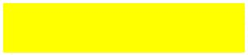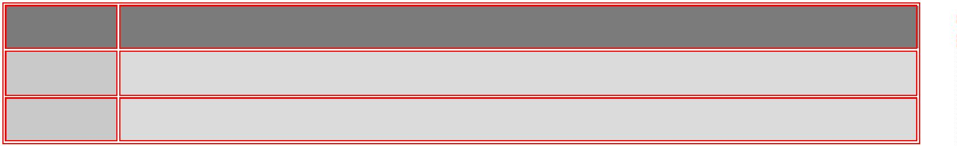1.1.1. 肯定的祈使句
①句型：动词原形＋其他成分。Be careful! 小心！
②＂Do＋祈使句＂表示一种强烈的感情或请求，do 起强调作用。
③please 用在祈使句中可以表示一种客气的语气，但 please 用在句末时，必须用逗号与其余部分隔开。
Close the door, please. 请关门。
1.1.2. 否定的祈使句
①常用句型：Don’t＋动词原形＋其他成分。Don’t be late for school again! 别再迟到了！
②用 Never 开头：Never＋动词原形＋其他成分。
1.1.3. Let 引导的祈使句
以 Let 开头的句子也是祈使句，表示陈述和建议。其否定形式有两种：Let...not 或 Don’t...
1.2 祈使句与简单句、复合句之间的转换
1.2.1. ＂Let’s + 动词原形 + 其他＂可转换为＂Shall we + 动词原形 + 其他? ＂。
1.2.2. ＂祈使句 + and/or + 简单句＂可转换为含 if 引导的条件状语从句的复合句。
1.3 祈使句的应答语
1.3.1. 以 Let’s 开头的祈使句，其答语常用 Good idea. /OK. /Yes, I’d love to. 等。
1.3.2. 其他肯定祈使句的应答语为 Yes, I will. ；否定祈使句的应答语为 Sorry/No, I won’t(do it again)。
2.must 的用法考点
2.1.must 表示义务，意为“必须”，强调说话人的主观意志。
例 You must work hard.你必须努力工作。
辨析：must 和 have to 的区别
情态动词 用法
must “必须”，表示说话人的主观意志；只有 must 这一种形式。
have to “必须，不得不”，强调客观需要；有人称、数和时态的变化。
例
You have to wear sports shoes when you climb a mountain.爬山的时候你必须穿运动鞋。
2.2.must 表示推测时，指有根据、有把握的推测，只能用于肯定句。可以对现在、过去或将
来的情况进行推测。
例 You must be a middle school student.你一定是一名中学生。
2.3.must 的否定形式 mustn't 意为“禁止，不许”，不能用来表示推测。表示否定推测时用 can't,
7
原创精品资源独家享有版权，侵权必究！
（北京）股份有限公司

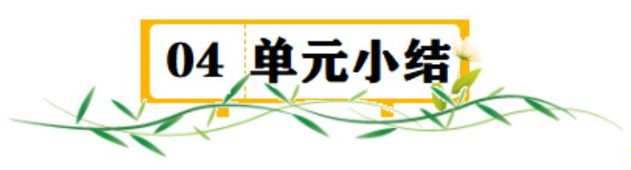意为“不可能”。
You mustn't park your car on this street.不许把车停在这条街道上。
2.4.由 must 引导的一般疑问句，肯定回答用“Yes,...must”，否定回答用＂No,...needn't/don't
have to”。
例－Must I learn these words by heart?我必须熟记这些单词吗？
－No,you needn't.不用。
一、单项选择
1．—Look at the sign. You ________ smoke here.
—Sorry, I won’t.
A．mustn’t B．needn’t C．shouldn’t D．may not
2．If you want to know more information about the Olympic Games, please ________ the Internet.
A．prepare B．search C．prepare for D．search for
3．—________ every day and you can have a strong body.
—OK. I hope to keep healthy.
A．Running B．Run C．Runs D．To run
4．—Tony, ________ bring your mobile phone to school.
—Sorry, Mr Green. I won’t.
A．can’t B．doesn’t C．don’t D．needn’t
5．—_______ I go to the movies with Jack, Mom?
—Sure, but you _______ be back by 9:00.
A．Can; may B．Should; must
C．Can; must D．Must; can
6．For your safety, you ______ wear the car belt and slow down while driving on highways.
A．might B．can C．need D．must
7．—Do I have to wash the dishes?
—Yes, you ________.
8
原创精品资源独家享有版权，侵权必究！
（北京）股份有限公司

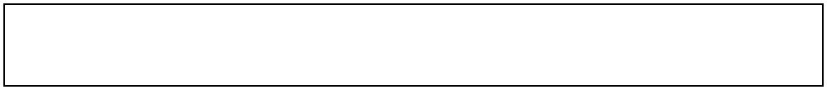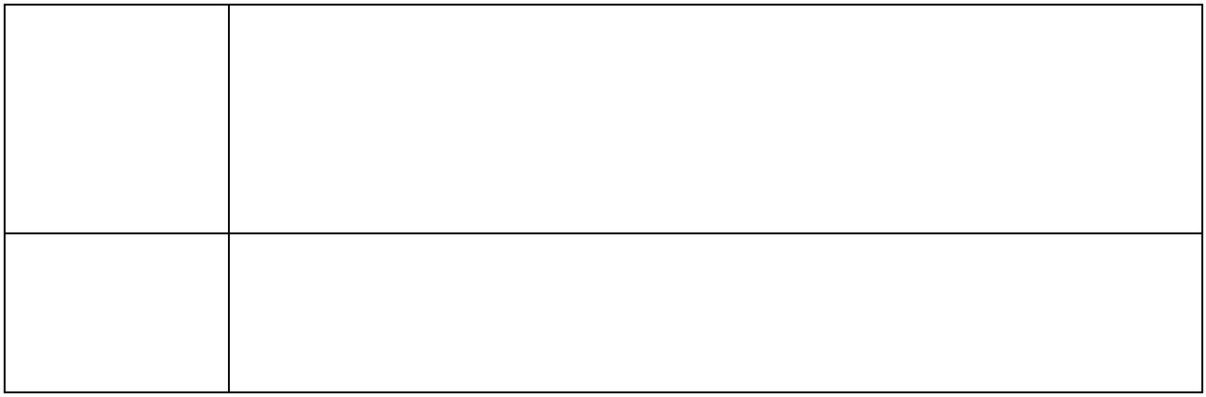A．do B．have C．must D．can
8．Excuse me, sir. You ________ open the door before the taxi stops.
A．mustn’t B．needn’t C．may not D．don’t have to
9．________ your hands before meals.
A．Washing B．To wash C．Wash D．Washes
10．—Let’s sing an English song here.
—________ that. Please keep quiet.
A．Do B．Don’t do C．Doing D．Does
二、选词填空
A．all right B．ask for C． beginning D．excuse
Here are some American classroom rules:
●If the teacher asks a question, you are expected to give an answer. If you don’t understand the question
or don’t know the answer, it’s 11 to tell the teacher that you don’t know. He or she then knows what
you need to learn.
●There is no 12 for not doing your homework. If you are absent, you should call your teacher
and 13 homework. It is your duty to find out what homework you have missed. It is not the teacher’s
responsibility to tell students about the homework they’ve missed.
三、阅读理解
Some students are talking about the rules in their family. Let’s see what rules they have at home.
1. Do homework when I get home from school.
Tom 2. Go to bed before 10:00 p.m. on weekdays.
3. Don’t play computer games on weekends.
1. Help parents do the housework on weekends. Lily
2. Don’t go out with friends at night.
9
原创精品资源独家享有版权，侵权必究！
（北京）股份有限公司

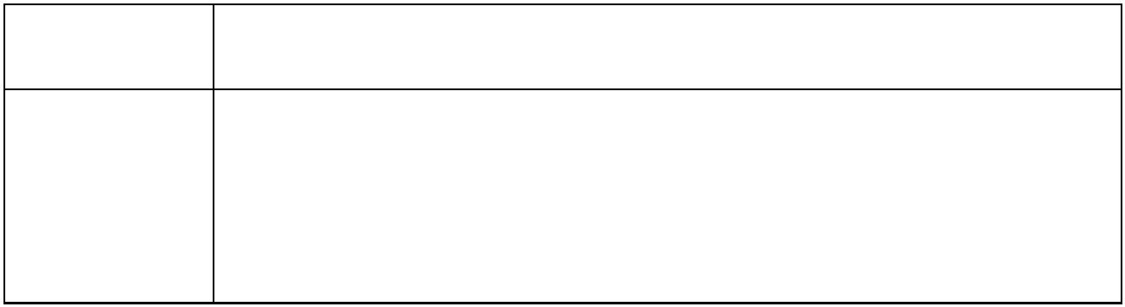3. Draw pictures for an hour every day on weekdays.
1. Get up early and make the bed.
Jack 2. Don’t eat fast food.
3. Do sports for about half an hour every day.
14．When does Tom go to bed on weekdays?
A．Before 10:00 p.m. B．Before 10:30 p.m. C．Before 11:00 p.m. D．Before
11:30 p.m.
15．What does Lily have to do on weekends?
A．Do her homework when she gets home from school.
B．Do sports for about half an hour.
C．Draw pictures for an hour.
D．Help her parents do the housework.
16．How long does Lily need to draw pictures every day on weekdays?
A．For 120 minutes. B．For 90 minutes.
C．For 60 minutes. D．For 30 minutes.
17．What can we learn from the text?
A．Tom can’t watch TV at home.
B．Lily can’t go out with friends at night.
C．Jack can’t play computer games after school.
D．The three students all have to do sports every day.
18．What is the text mainly about?
A．School life. B．Family rules.
C．Family activities. D．Daily life.
My name is Tina. There are many rules in my life. I think these rules are important for me.
At home, I can’t play computer games on weekdays. I can play them for only half an hour on Sunday
afternoon. I think it is good for my study because I can have much time to study. I must make the bed after I get
up. _______ So my bedroom is always clean and tidy. My mother says keeping the room tidy is good for my
health.
10
原创精品资源独家享有版权，侵权必究！
（北京）股份有限公司

I study at Sunny Middle School. It is big and new. At our school, we also have some rules. We can’t be late
for school. So we must arrive at school on time. We must get to school before eight in the morning. We need to
wear the school uniform every day. In class, we have to be quiet. We can’t listen to music. We can’t eat in the
class. We must eat in the dining hall. After class, we can’t run in the hallways.
Do you have rules in your life? Tell me about them.
19．What does Tina think of the rules in her life?
A．Strict. B．Strange. C．Important. D．Interesting.
20．How long can Tina play computer games every week?
A．For 30 minutes.B．For 35 minutes. C．For 40 minutes. D．For 45 minutes.
21．Which sentence can be put in the “_______” ?
A．And I can listen to music in my room. B．And I have to brush my teeth after dinner.
C．And I should read for an hour with friends. D．And I must clean my room every day.
22．When can Tina arrive at school?
A．At 7:50 a. m. B．At 8:10 a. m. C．At 8:20 a. m. D．At 8:30 a. m.
23．What is the text mainly about?
A．Rules in Tina’s life. B．Rules at Tina’s home. C．Tina’s school life. D．Tina’
s tidy room.
四、完形填空
阅读短文，根据短文内容从各题所给的四个选项中选择最佳选项。
Dear Dr. Know,
I’m not happy. I have too many rules（规矩）in my family. I have to 24 up at 6:00 every
morning. I can’t be late 25 school. I can’t meet my friends after school 26 I have to take my
dog for a walk. I have to get home at 5:00 pm. I can’t watch TV on school nights. And I have to be in bed by ten o’
clock. On weekends, I have to clean my room and wash my clothes in the morning. Then I have to 27
English books. Later in the afternoon I have to go to the Children’s Palace to 28 how to play the piano.
In the 29 , I have to play the piano for one hour. After that, I can go to bed. I don’t have any free time.
What can I do?
11
原创精品资源独家享有版权，侵权必究！
（北京）股份有限公司

Yours,
Susan
24．A．get B．call C．go D．come
25．A．at B．for C．on D．in
26．A．when B．so C．because D．why
27．A．write B．buy C．watch D．read
28．A．tell B．say C．see D．learn
29．A．morning B．afternoon C．evening D．class
五、短文填空
Read the passage and fill in the blanks with proper words (在短文的空格内填入适当的词，使其内容通顺，每
空格限填一词，首字母已给)
Traveling by subway can sometimes be quite “exciting”, especially (尤其) when there are too many people
on the subway. Sometimes you have to stay a 30 from hot water and coffee because it may spill (泼洒)
on you.
Passengers mustn’t eat or drink on the subway in some cities. According to the new subway rules in Beijing,
only babies and sick people can eat and drink on the subway. If anyone else b 31 the rules, he or she
must get off. In other cities like Shenzhen and Nanjing, if passengers eat or drink on the subway, they will be
fined (罚款).
Some people agree with the rules. They think the smells of food can make other passengers feel u 32
or angry because they fill (弥漫) the whole subway, especially in the hot summer. And if passengers eat or drink
on the subway, people often spill their drinks. These things make the subway dirty.
H 33 , some people are not happy with the rules. They think some people eat and drink on the
subway because they live so far from their workplaces. They have no time to have breakfast before they go to
work. E 34 on the subway saves their time.
As for me, I think we should think more about people’s needs. We can p 35 some special places
in many subway stations for passengers to eat and drink.
12
原创精品资源独家享有版权，侵权必究！
（北京）股份有限公司

六、任务型阅读
阅读下面短文， 简略回答问题。
A School Trip
Attention, please! I have something important to say. We’ll go on a school trip to the art museum this
Friday. Here are some rules (规则) that we have to follow.
To start with, you must be quiet in the museum. If you speak loudly, the workers in the museum will ask
you to leave. Next, don’t take photos in the museum, because it’s bad for the paintings. But you can take a pen
and a notebook to write down some important things. Finally, keep the museum clean and tidy while visiting. By
the way, please call 2436-7866 if you have any questions. I hope we will have a good time there. That’s all. Thank
you.
36．When will the students visit the art museum?
37．What can the students take to write down important things?
38．What can the students do if they have any questions about this trip?
39．How many rules are there in the passage?
40．What other rules for the museum do you know? (写出一个答案即可)
七、书面表达
41．俗话说 “没有规矩不成方圆”。规则帮助我们更好地生活，可见规则是多么重要。请你以“The
Importance of Rules”为题，用英语写一篇短文，向大家介绍一下规则的重要性。
写作要求：（1）文中须列举至少规则的三个重要性，可适当发挥；
（2）文中不得出现考生的真实姓名和学校名称；
（3）词数 70 词左右（开头和结尾已给出，不计入总词数）。
13
原创精品资源独家享有版权，侵权必究！
（北京）股份有限公司

提示词：area 区域，方面
The Importance of Rules Rules are very important in our life.
___________________________________________________________________________________________
___________________________________________________________________________________________
___________________________________________________________________________________________
___________________________________________________________________________________________
___________________________________________________________________________________________
___________________________________________________________________________________________
___________________________________________________________________________________________
____
Rules are good for us. We should follow rules in all areas of our life.
14
原创精品资源独家享有版权，侵权必究！
（北京）股份有限公司

